Code-Reactors NFT Marketplace

This is a Blockchain-based E-Commerce warranty system using NFTs. Created with Solidity, Hardhat, ReactJS.

To setup the project :

* Unzip the project open in VScode run: npm install

(NOTE : If it shows error run: npm install --force )

* Open three PowerShell run
  + In first PowerShell run command: npm run node - to start a local EVM blockchain testnet.
  + In second PowerShell run command: npm run setup - to deploy NFT and Marketplace contracts.
  + In third PowerShell run command: npm run dev - to start frontend application
* Install Metamask, add extension to chrome, import or create wallet
* To add localhost chain :

|  |  |
| --- | --- |
|  |  |

* Open <http://localhost:3000/> in chrome connect with your wallet
* Make sure to use Localhost chain as the Metamask's network
* Import wallet of Retailer for testnet and creation of NFT, connect this account and create NFT: private key is: 59c6995e998f97a5a0044966f0945389dc9e86dae88c7a8412f4603b6b78690d

|  |  |
| --- | --- |
|  |  |

* Connect another testnet account for buy sell purpose.
  + You can import account from node server, by copying private key from PowerShell and importing the wallet in metamask.
  + OR else you can simply import wallet: private key is: 0x4bbbf85ce3377467afe5d46f804f221813b2bb87f24d81f60f1fcdbf7cbf4356
* Setup is over you are ready to create NFT by switching to Retailer account.
* Once NFT listed try to buy it from costumer’s account.
* Find Difficulty follow this video: https://www.youtube.com/watch?v=bJqFZLC4_tw

Solution For Different Errors

1. If you haven’t install meta mask extension in your browser then below error is shown

* 1. Solution: Install metamask -> create/import account

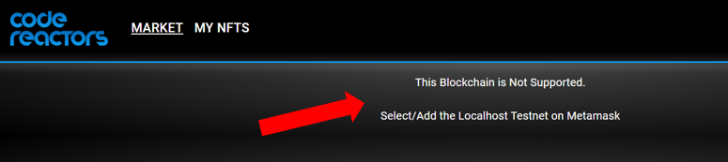

* 1. Switch to localhost testnet if you have already created.

1. While creating NFT if below error appears then wait and retry after some time... because server is not able to fetch a file from IPFS.

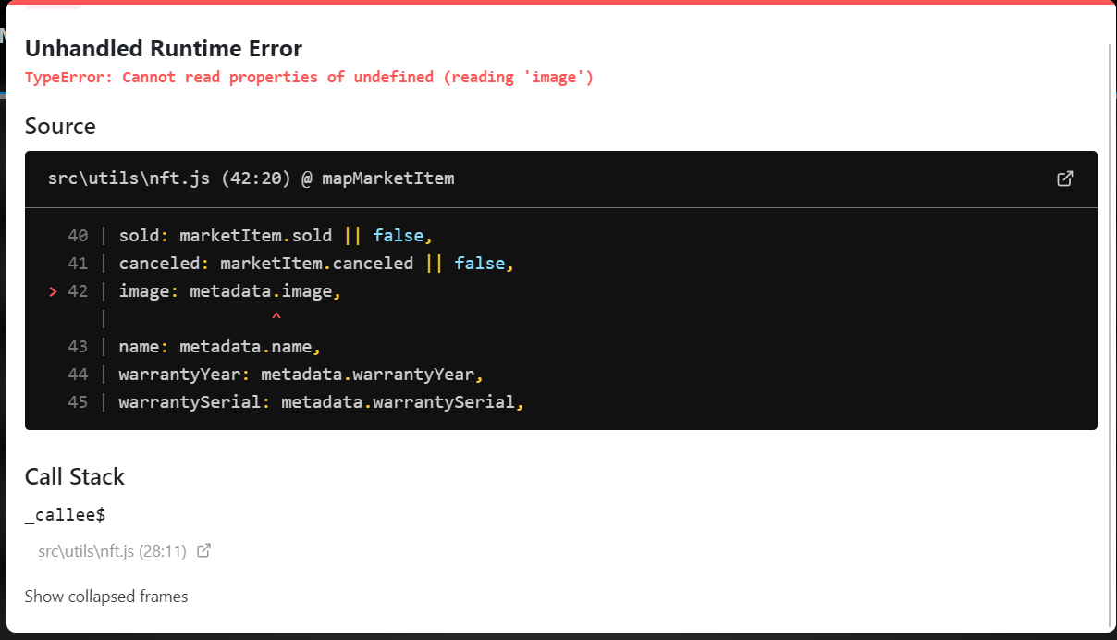

1. If below error is shown during minting or creation of new NFT, then reset your metamask account.

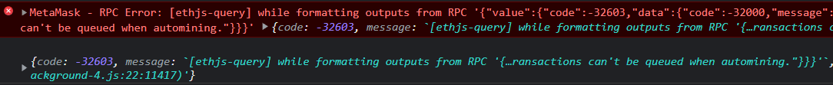

To reset account: Open metamask -> setting -> advance -> reset account

